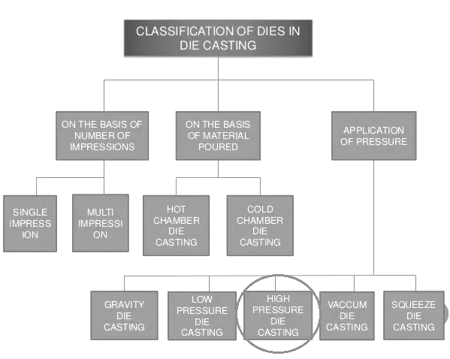

HPDC

High-pressure die casting is a process wherein molten metal is forced, under pressure, into a sealed mould cavity. It is held in place by a powerful compressive power (true die installed in a hydraulic machine) until the metal solidifies.

Following solidification, the die is released, opened and the metal is released.

Following removal, the mould cavity is resealed for the next cycle.

Molten metal injection into the mould cavity occurs in a fraction of a second (usually under 100 ms). Oncedie cavity is filled, extremely high pressure is applied (often over 1000 bar) into a molten metal true injection plunger. This phase is called intensification.

This pressure compresses out any gases trapped in the metal (during extremely fast and turbulent cavity filling) and feeds more metal into the mould to partially compensate for the shrinkage in the metal whilst it is solidifying.

In addition to traditional high-pressure die casting methods, over recent years there have been a number of improvements in the process. For example: Vacuum die casting, Semi-solid casting, Squeeze casting, etc.

High pressure die-casting:
In order to inject molten metal into the mould, two different systems may be used:

- Hot chamber system
- Cold chamber system

The hot chamber system:
The hot chamber system is used with metals such as zinc, magnesium and lead.

The injection system for a hot chamber machine is immersed in molten metal from the blast furnace. When the piston pumps, it forces metal along the nozzle and into the die.

The cold chamber system:
The cold chamber system is used for metals which melt at high temperatures, such as aluminium, copper and magnesium.

Magnesium parts can be produced by using either systems, although generally speaking small parts are made in hot chamber systems, whilst large parts in cold chamber systems, as hot chamber machines have limited dimensions.

In this system higher pressure is used compared to the hot chamber system. The production rate of a hot chamber machine is higher than that of a cold chamber since less time is required for the pouring process.

The cold chamber system also uses two injections systems in the process:

- Horizontal injection
- Vertical injection

In this system, the molten metal is poured, either manually or automatically, into an opening leading to a channel feeding the cold chamber.

A piston which is hydraulically activated moves down this steel channel, blocking light and pushing the metal into the mould at high speed and pressure.

Following solidification of the flow, the piston is pulled back, and the mould opened, the flow is expelled and the system is ready to be activated again.

Advantages of high pressure die casting:

The advantages of high pressure die casting include higher production speeds when compared to the flow pouring under the effect of gravity.

Furthermore, the ability to produce flows of specific dimensions notably reduces processing operations.

The fusions have a good surface finish, which is a basic requisite for plating, and reduced thickness of the plate walls is made possible by reducing the overall weight of the fusion.

The moulds are durable, thus reducing unit cost prices and more complex parts can be manufactured, thus decreasing the number of components requested each time.

High-pressure die casting is used to create everything from engine blocks to aerospace components and even heavy-duty fasteners. While there are different ways to perform it, most high-pressure die casting processes consist of the four following steps:

#1) Preparing the Mold:
The first step of high-pressure die casting is mold preparation. During this initial step, the manufacturing company applies a lubricant to the interior walls of the mold. This is important because the lubricant regulates the mold’s temperature while also creating a film between the molten metal and the mold, thereby allowing for easier removal of the casting.

#2) Injection
After preparing the die mold, the manufacturing company injects it with molten metal. The mold must be completely closed and sealed during this step. Otherwise, it won’t be able to “accept” the highly pressurized molten metal. Depending on the specific application, the molten metal may be injected into the mold at a pressure of between 1,500 to 25,000 pounds per square inch (PSI). The mold maintains this pressure until the molten metal has cooled and solidified.

#3) Cavity Ejection
Next, the manufacturing company ejects the newly made cavity from the mold. The mold itself typically features ejector pins that, when engaged, release the cavity. Of course, the cavity must be solid for it to eject. If the raw metal is still liquid, the manufacturing company must wait for it to cool before it can eject the cavity from the mold.

#4) Shakeout
The fourth and final step of high-pressure die casting is shakeout. During this step, the manufacturing company separates any scrap metal from the newly created cavity. It’s not uncommon for high-pressure die casting to produce excess scrap metal. In other words, not all of the molten metal is used to create the casting. Some remains stuck inside the mold. As a result, the scrap metal must be removed before the mold can be reused..

The basic functional parts in a HPDC die or injection molding mould are:

Cavity and Cores (which give the shape to the casting or molding) :
Core: It is male part which form internal shape of molding
Cavity: It is the female part which form external shape of molding

Runner system: It leads the molten raw material from the machine injec-tion/shot system to the cavities

Core moving mechanisms: It will move the movable cores in in the beginning of the machine cycle and out along with the mould/die opening.

Ejecting mechanism: It removes the part from the cavity together with the machine ejection system.

Cooling/tempering channels: It keeps the thermal balance during moulding or casting operations.

The mould/die functional parts act together with the casting/moulding machine. In the machine there are parts for dosing the raw material into the mould/die, parts for producing the core moving forces (electrical, hydraulic or pneumatic), parts for producing the forces for ejection (electrical or hydraulic) and parts for circulating the cooling liquid inside the mould cooling tempering channels.

The space inside the mould in which the part is shaped is called a mould cavity. The surface between the fixed and movable halves is called a parting surface. As the first choice the parting surface should be planar. Only if it is absolutely necessary to make a stepped or shaped parting surface, this option could be taken into consideration. The two mould halves need to fit tightly together.
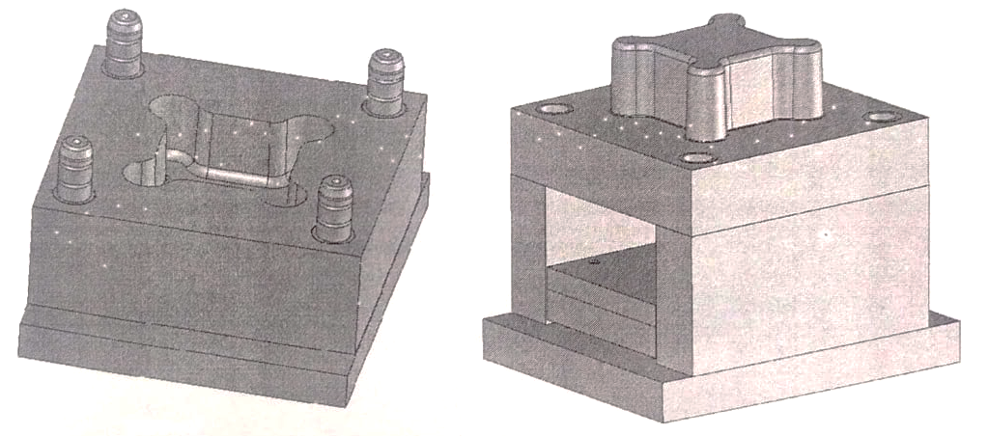

Image 2:
Left: Mould fixed side with the cavity. The space inside which the part is shaped, is also called a cavity. Right: Mould movable side with a core. The surface between these mould halves is called a parting surface.

DRAFT ANGLE-
All cores are prepared with angled vertical surfaces. None of the vertical surfaces is perpendicular to the parting surface. The angle is called a draft. All moulded part or high pressure die casting vertical surfaces must be prepared with a draft angle. Otherwise it is not possible to eject the casting out of the mould.

A core is any extension in the mould. There are two types of cores: fixed and moving. Note that an extension in the mould is a recession or hole in the part. The fixed cores can be either separated parts or just machined extensions in the mould cavity plates (See image next page.). The part fastens around a core, because all injection mould able plastics and high pressure die castable metals shrink during cooling. It is practical to place the part into the mould so that as many cores as possible are located in the moving side and as much of the cavity as possible in the fixed side like in the image above. This arrangement fastens the molded part to the moving
side and makes it possible to eject it in the right time.

There are three basic structures:

a slide mechanism, a pulling cylinder and a string loaded pulling mechanism.

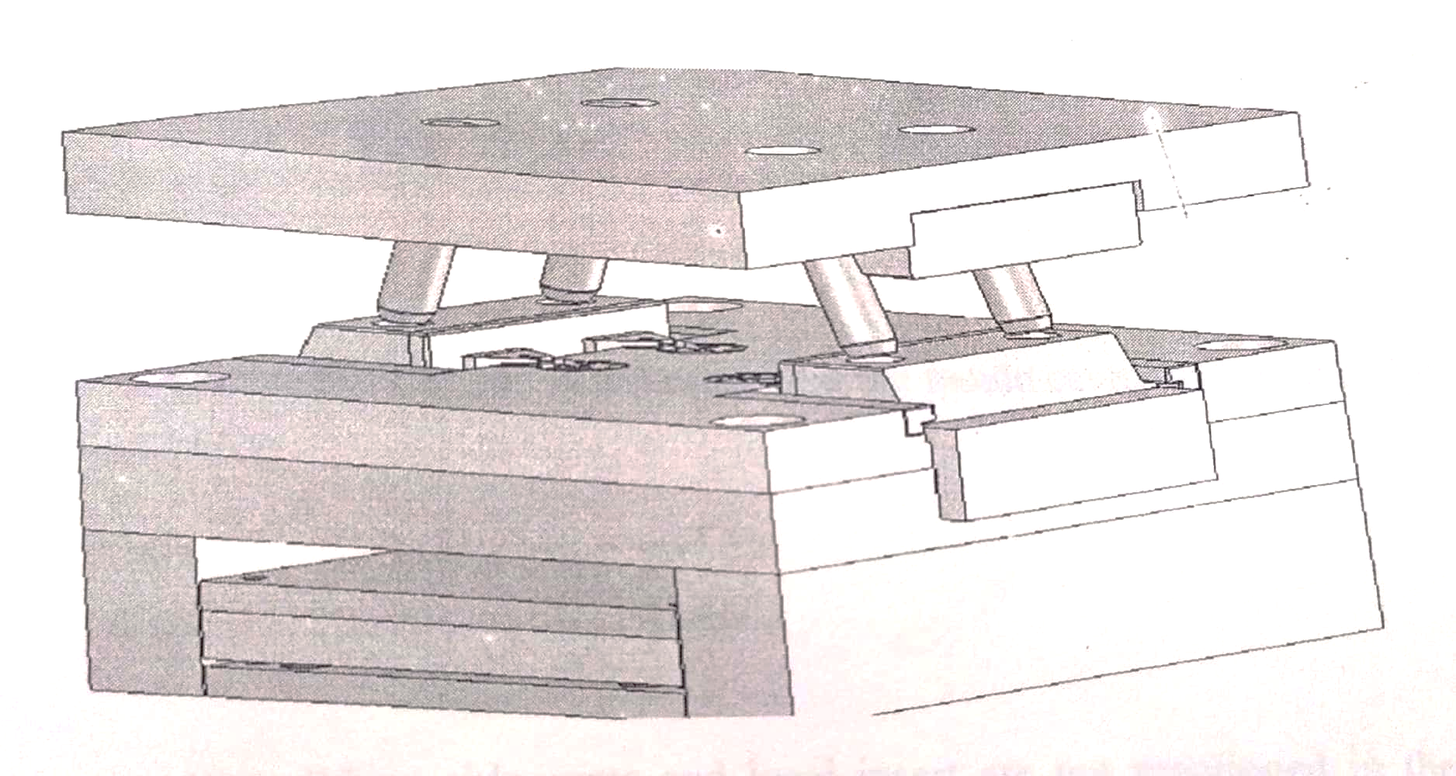

Image 3. A sliding core mechanism. The basic components in this system are: angle pins, slides, guiding rails and slide locking components. The idea is to move cores out of the part during the mould opening movement. After the cores are removed, the ejection is possible.

The part is removed from the mould cavity with standard mould parts called ejectors. Ejectors are round, flat or cylinder shaped pins with a collar on one end. The ejectors are fastened with this collar between the ejector set plates, ejector base plate and ejector retaining plate. (See image 2.) The ejector set is guided with strong ejector pins, ejector returning pins or with special guiding components.

The ejector set is fastened to the injection moulding or high pressure die casting machine ejection system. A high pressure die casting mould is fastened with four ejection bars. An injection moulding mould is typically fastened with one ejector pushing component which is placed into the middle of the ejector set plates. Typically the high pressure die casting die ejection set needs only a light guiding system or no guiding at all.
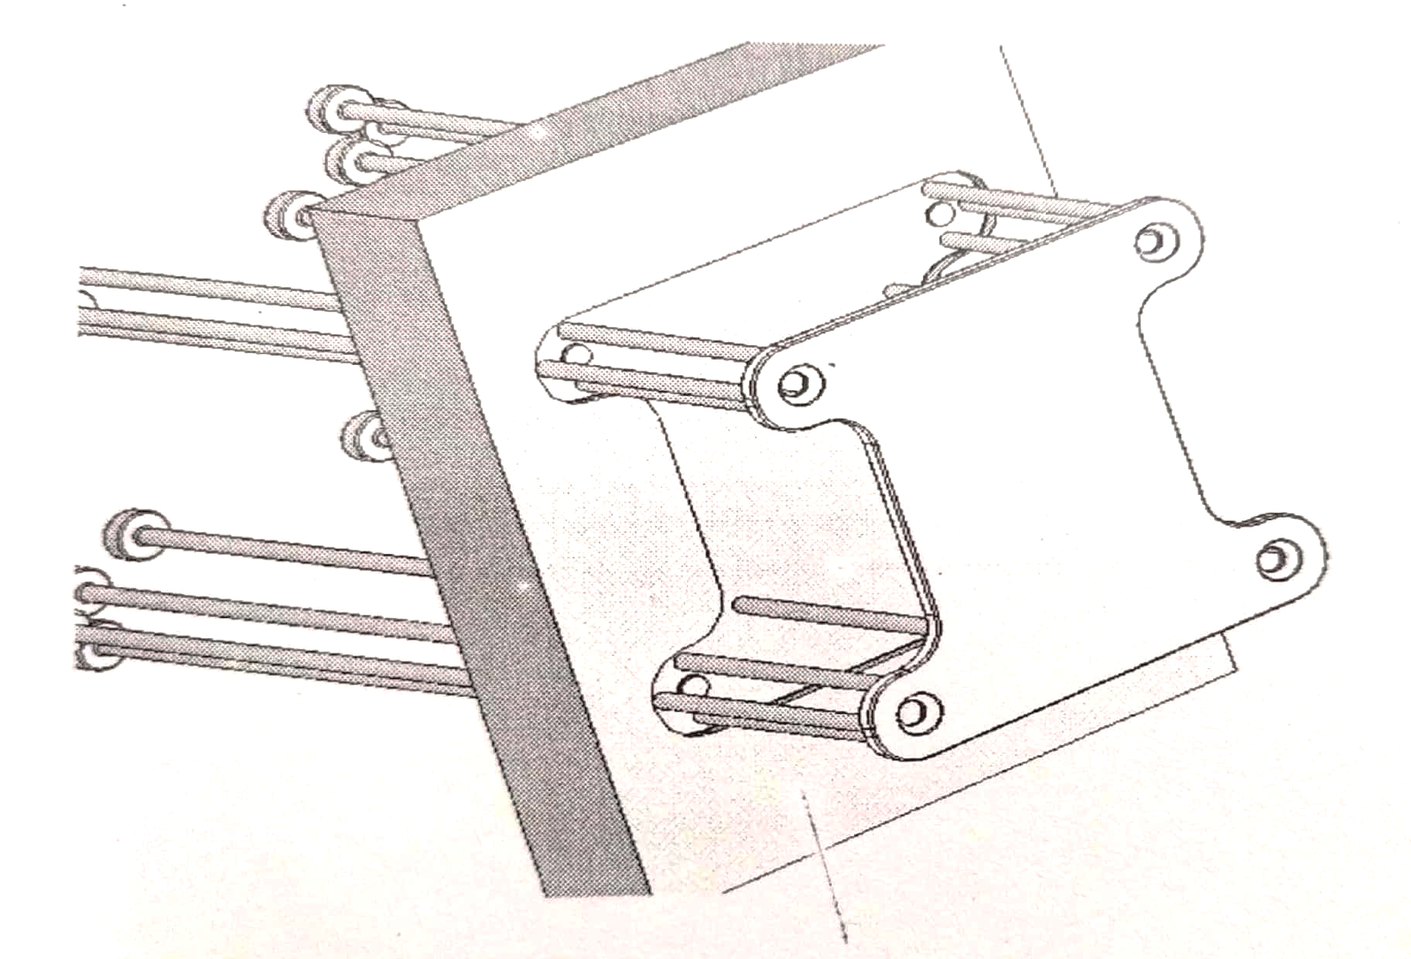
Image. Ejector pins. The part is removed from the mould cavity with round, flat or cylinder shaped ejectors

Some part like sliders, side cores and local insert are not mentioned in the above schematic diagram, these get incorporated into the BOM (Bill of material) which is the list of all materials used for manufacturing of the die

